Underwater wireless video communication
in operations of AUV/UUVs –
new horizon of underwater explorations

Kirill Otradnov, Volodymyr Shuliak, Sergii Kornieiev

BaltRobotics Sp.z.o.o., Limited liability company
3, str. Trzy Lipy, Gdansk, 80-172, Poland
sergii.kornieiev@baltrobotics.com, orcid.org/0000-0003-3969-0304

Summary. This article presents the experience of BaltRobotics® in the development, production and testing of wireless underwater acoustic video communications − unique in the world technology today. It is also considered the use of wireless underwater video implementation in Autonomous Underwater Vehicles (AUV’s) as applied to perform inspections of underwater oil and gas pipelines and other applications. The achieved characteristics, limitations and coming prospects were presented.
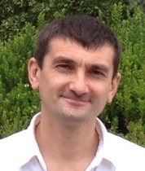

Volodymyr Shuliak
Partner
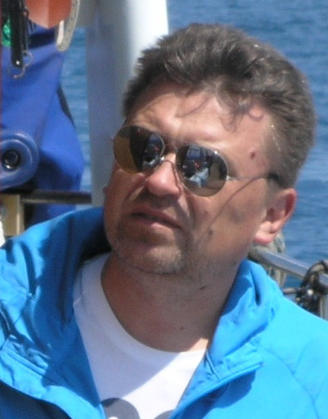

Kirill Otradnov
Chief Technical Officer /
Partner
Key words: Wireless underwater video communications, acoustics, AUV, ROV, offshore, oil&gas, NDT, underwater pipelines inspections.

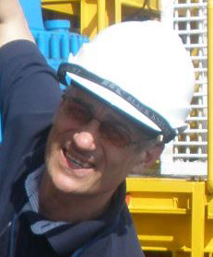

Sergii Kornieiev
President /
Chief Executive Officer
THE ISSUE & CHALLENGE

Currently, there are about 1000 Remotely Operated Vehicles (ROV) units and up to 700 AUVs (Autonomous Underwater Vehicle) in the world [1].
In the upcoming 4 − 5 years it is expected that this fleet can be increased 50…60% according to «most likely» scenario and can even be more than doubled according to “High Case” scenario.
The vast majority of AUVs currently belongs to defense – as “Unmanned Underwater Vehicles” (UUV, − UUV and AUV have no differences in the meaning, but the abbreviation “UUV ” is used in the defense industry).

Of these, approximately 35% are "heavy", 25% − "middle", and 40% − “light” vehicles. The majority of heavy ROV vehicles is used in drilling and construction support of subsea infrastructure in oil & gas industry. Light ROV vehicles are used in Inspection Repair and Maintenance (IRM). Approximately 70…80 percent of all ROV’s are “heavy” to “medium and 20…30% are “light” vehicles. IRM-segment of the market for “light ROV” was in 2015 – 17% and as estimated will grow 3,8% till 2019 [2].
As market tendency there are the attempts to spread AUV/UUV applications from the defense to “civil market”, with this it is assumed that AUV’s will take over some IRM tasks from ROV’s.
Much attention is paid to «Deep Water» − ROV & AUV operations in depths up till 3000 meter of water. Although from a market point of view, such "frontier types” of vehicles will not be decisive because of about 80% of the total pipelines length (and oil&gas platforms and undersea infrastructure) belong to the depths less 500 meters.
The service delivery market of IRM is highly monopolized: 60% of all ROVs owned by top three operators, 22% − owned next four, 18% remaining – spread across 10 other smaller ROV-operators.
With AUV/UUV the development really is in the “start position” when we see the civil tasks. There are only about 30 units in the operations out of defense applications. About 10 companies have its own AUV/UUV design. BaltRobotics is one of them [3].
In the last 2 − 3 years the Oil & Gas industry has been under "pressure", which has resulted in a challenge to reduce prices which results in a critical review of approaches to development in the industry.
For example, with regards to IRM of underwater pipelines. Currently the total length of pipelines in the world is estimated as 150 thousand km, and still increasing with 20% towards 2019. As a great part of these pipelines is older than 20 − 25 years − their end of life cycle. Ecological requirements will press the operators through governmental regulations to increase IRM operations with the increasing of “age” of pipelines despite the decline in oil prices. Another thing is that the need to optimize the budgets in this situation requires the introduction of new advanced technologies, including the transition from ROV-based inspections to AUV-based ones.
Thus, the objective reasons and formal requirements force operators to increase the operating costs when the optimization of budgets is in the urgent agenda!
What does this means “in money”? – The rent of a vessel with an ROV is roughly estimated around $100 thousand per day – it depends from the depth and the amount we mentioned belong to the “shallow water” experience. In the “deep water” the rates are higher. The "availability factor" taking into account of weather condition influence is about 0,3 − in the equatorial regions, − and in the North Sea – less. In theory Vessel & ROV can inspect some 10…20 km, but really with the missed days/weeks of hard weather the average productivity per day usually lays – 2…5 km.
With this initial data we can calculate: if
“5 кm” the financing of the inspection of 25% of extent should around $2…3 billion! This is serious amount. Although, if considering that BP paid 62 billion dollars for the accident in 2010 at the Deepwater Horizon spill, and the real damage to nature no one can really estimate the costs of 4 billion seem to be fully justified. Anyway, any possible optimizations will be welcomed by operators.
Also there are some limitations with ROVs: "hooks" of tethers, "start" and "extracting" breaks, etc., which was observed with waves of 1…1,5 m. And with waves 2,5 m the vessels with ROV must stop productive work.
How can we optimize the costs? The general approach the same in any industry – it is automation! In the case we can reach the enlarged effectiveness if we will expand the limits for weather conditions and will have more "availability factor". The first and the second lead to AUVs instead of ROVs.
“The lack of breakthroughs in wireless underwater communication and battery capacity is prolonging the wait for a fully autonomous underwater vehicle (AUV), one that will not need a $100,000/day vessel and crew <authors’: as ROV-approach>, a heavy tether for power and control or hours to complete a task that might take minutes onshore…” [4].
This quote clarifies the essence of the problem: to go to the automatic inspection on the basis of AUVs it was necessary at the first to solve the problem of transmitting video wirelessly. The problem of power is not very critical now for light AUVs, it is quite acceptable with the batteries that provide mission durations of up to 24 hours or even more. When an AUV can cruise up to a speed of 5 knots it has the possibility of carrying out inspections at a distance of 100 km!

THE HISTORY OF WIRELESS UNDERWATER VIDEO DEVELOPMENT

Dozens of scientific and industrial groups from almost all the leading countries of the world are involving in the development of over the past 20 years.
The most development activities had been done in Massachusetts Institute of Technology (MIT), Georgia Institute of Technology, State University of New Jersey, University of Connecticut, Boise State University, The University of Texas at Austin, Missouri University of Science and Technology, Florida Atlantic University, University of Delaware (all USA), and also some scientific teams from UK, France and Italy, in particular G.E.S.M.A. (Groupe d’Etudes Sous-Marines de l’Atlantique), Naval Brest, France.
The results of the researches can be resumed that it was revealed that the wireless acoustic communications can be realized with the rate 115…128 kbit/s and the distances 100…200m. But in USA market and in the world one also you can buy only modems with 62 kbit/s with the range 300 m − not more.
Data transmission schemes used:
- orthogonal frequency division multiplexing (OFDM);
- frequency shift keying (FSK);
- direct sequence spread spectrum (DSSS);
- single carrier phase-coherent modulation with adaptive channel equalization − direct transmission of phase-coherent modulations, including: phase shift keying (PSK) and quadrature amplitude modulation (QAM);
- multiple-input multiple-output (MIMO).

Modulation schemes with modulation efficiencies are in Table [6].
Table. Modulation schemes with modulation efficiencies

Modulation scheme | Modulation efficiency,  bits/s/Hz
DPSK | 0,8
BPSK | 1
QPSK | 1…1,6 (typ)  2 (max)
8 PSK | 2,75 (typ)  3 (max)
16 PSK | 4
16 QAM | 4
64 QAM | 6

QAM is used extensively as a modulation scheme for digital telecommunication systems. Spectral efficiencies of 6 bits/s/Hz can be achieved with QAM (64 QAM) – but taking into account the reliability of communications the real figures are about 2 bits/s/Hz.
As system requirements for video transmission bit error rate (BER) should be:
~ 10⁻³…10⁻⁴.
“Applied Ocean System” proposed “See-Horse” Wireless Underwater Digital Video Transmission System but there are no data about the channel characteristics; and the system is not integrated with AUVs.

THE NATURAL OBSTACLES

Among the three types of waves (electro-magnetic waves, acoustic waves and optical waves (lasers)), acoustic waves are used as the primary carrier for underwater wireless communication systems due to the relatively low absorption in underwater environments.
But the use of acoustic waves especially in shallow water can be adversely affected by Doppler effect, temperature gradients, surface ambient noise, and multipath propagation due to reflection and refraction.

Propagation velocity
The much slower speed of acoustic propagation in water, about 1520 m/s (meters per second), compared with that of electromagnetic and optical waves, is another limiting factor for efficient communication and networking. The matter is not only in the “slow speed” when you need only transmit video. But in our case we need also to control AUV from operator. In the case we have the delay for signal propagation – every 152 m “deliver” the delay 0,1 s. It is not much but there will be also the delay for data processing! We will discuss this issue below.
A typical speed of sound in water near the ocean surface is about 1520 m/s. The speed of sound in water increases with increasing water temperature, increasing salinity and increasing depth. Most of the changes in sound speed in the surface ocean are due to the changes in temperature. This is because the effect of salinity on sound speed is small and salinity changes in the open ocean are small. Near shore and in estuaries, where the salinity varies greatly, salinity can have a more significant effect on the speed of sound in water. As depth increases, the pressure of water has the largest effect on the speed of sound. Under most conditions the speed of sound in water is simple to understand. Sound will travel faster in warmer water and slower in colder water. Approximately, the sound speed increases 4,0 m/s for water temperature arising 1˚±C˚. When salinity increases 1 practical salinity unit (PSU), the sound speed in water increases 1,4 m/s. As the depth of water (therefore also the pressure) increases 1 km, the sound speed increases roughly 17 m/s.
It is noteworthy to point out that the above assessments are only for rough quantitative or qualitative discussions, and the variations in sound speed for a given property are not linear in general. But the communication system has to follow and carry out these dependences!

Absorption
During propagation, wave energy may be converted to other forms and absorbed by the medium. The absorptive energy loss is directly controlled by the material imperfection for the type of physical wave propagating through it. For acoustic waves, this material imperfection is the inelasticity, which converts the wave energy into heat. The absorptive loss for acoustic wave propagation is frequency-dependent. For the frequency range (0,5…1,0) MHz (that is the only can deliver to us the signal bandwidth till 80 kHz with practical intended distances till 200m) – the absorption about 200…300 dB/km.
One more serious limitation is that you could not increase the power of transmitter for your choice – you will be limited with cavitation effect – the water will be “boiled” on the antenna’s surface when transmission power increased and the range of communication immediately dropped down.

Multipath
An acoustic wave can reach a certain point through multiple paths. In a shallow water environment, where the transmission distance is larger than the water depth, wave reflections from the surface and the bottom generate multiple arrivals of the same signal. In deep water applications, surface and bottom reflections may be neglected. Due to the spatially varying sound speed, the wave refractions, however, can cause significant multipath phenomena.
Large channel delay spread introduces time dispersion of a signal, which causes severe inter-symbol interference. This brings grand challenges for efficient modulation and demodulation.

Path Loss
For any propagation wave, there are three primary mechanisms for energy loss: (i) geometric spreading, (ii) absorptive loss, and (iii) scattering loss. We next focus on geometric spreading and scattering loss. Geometric spreading is the local power loss of a propagating acoustic wave due to energy conservation. When an acoustic impulse propagates away from its source with longer and longer distance, the wave front occupies larger and larger surface area. Hence, the wave energy in each unit surface (also called energy flow) becomes less and less. For the spherical wave generated by a point source, the power loss caused by geometric spreading is proportional to the square of the distance.
Scattering is a general physical process whereby one or more localized non-uniformities in the medium, such as particles and bubbles, force some forms of wave radiation to deviate from a straight trajectory. It also includes deviation of reflected radiation from the angle predicted by the law of reflection. This is especially relevant to underwater channels. When the wind speed increases, the surface roughens and the effect of surface scattering becomes evident.
Surface scattering introduces not only power loss, but also spreading in delay of each surface bounce path (thus contributes to multipath phenomena).

Ambient Noise
Ambient noise is defined as “The noise associated with the background din emanating from a myriad of unidentified sources: its distinguishing features are that it is due to multiple sources, individual sources are not identified, and no one source dominates the received field”. The common sea-surface noise sources include the surface-ship radiated noises, breaking waves associated with ensuing bubble production, and so on; and the deep water noises mainly come from marine animals. Moreover, surface ships that cross ocean basins could produce a general low frequency background traffic noise that may not in fact sound like coming from surface shipping. The level of underwater ambient noise may have large fluctuations upon a change in time, location or depth. Nevertheless, it is still possible to sketch out a function describing the approximate magnitude range to characterize underwater ambient noises in very general terms. Often pressure spectral density, defined as the mean squared pressure of noise within a given frequency band divided by the bandwidth f, is used. The unit of pressure spectral density is pressure squared per Hertz. It should be noted that noise level is frequency-dependent. When (0,5…1,0) MHz is used – roughly we can estimate Ambient noise as Intensity Spectral Density 10⁻¹⁴…10⁻¹⁶ (W/m²/Hz).

Time-dispersion
Slow speed of acoustic waves and significant multipath phenomena cause very large channel delay spread, which leads to severe inter-symbol interference due to the waveform time-dispersion (also called time-spreading).

Doppler spread
In motion environments (such as platform motion, scattering of the moving sea surface, AUV motion), the slow propagation speed of sound introduces large Doppler spread or shifts, which causes severe interference among different frequency components of the signal (also referred to as frequency-spreading). On the outset, large Doppler spread results in a reduction in the channel coherence time (the time period when the channel can be viewed as static) or an apparent increase in the rate of channel fluctuation. The ratio of Doppler to carrier frequency in underwater channels is on the order of 10⁻³ to 10⁻⁴.
In short, the objective of underwater acoustic communication is to overcome the performance limitations induced by the highly dispersive channel, while at the same time improve the bandwidth efficiency as much as possible.
BaltRobotics have designed the solution and successfully tested it in the mode “point-to-point” with the presence of invited international experts in Burgos (Bulgaria) in 2011, − till now it is the only solution in the world! In Fig.1: the moment when one of the high data rate modems had being immersed down.

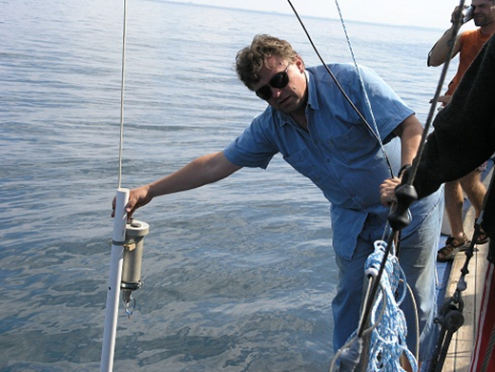

Fig.1. Burgos, Bulgaria, September, 2011:
the first wireless underwater acoustic video channel is going to start the “new era” of underwater development

ALTERNATIVES AVAILABLE

Free-space optical (FSO) waves used as wireless communication carriers are generally limited to very short distances because the severe water absorption at the optical frequency band and strong backscatter from suspending particles. Even the clearest water has 1000 times the attenuation of clear air, and turbid water has more than 100 times the attenuation of the densest fog.
Nevertheless, underwater FSO, especially in the blue-green wavelengths (450…550 nm), offers a practical choice for high-bandwidth communication − 10 Mbps with negligible delay over moderate ranges − up to about 100 m. The solution had been designed by Woods Hole Oceanographic Institution (WHOI, USA). It was reported in November, 2012 the WHOI have developed a wireless underwater communication system to control remotely operated vehicles (ROVs) in real time. It was reported in [9] the WHOI optical modem had been used for communication with AUV.
There are two main disadvantages of Free-space optical approach: 1) very large dependence from transparency of water – in some area of offshore oil&gas platforms one cannot see his arm in the water (!) – that can decrease the range to several meters as the most; 2) very narrow beam to reach the longest range that needs high precision of antennas’ orientation and control system.

VIDEO DATA COMPRESSION

The limiting factor in video technology is not only the sensors, but also the corresponding data rate which results for high resolution and high frame rates. Using the example above, a 720×640 at 30 Hz camera with 12 bits conversion depth will yield around 165Mbit/s uncompressed. To transmit this data flow with Modulation efficiency 2 bits/s/Hz one needs the bandwidth 82,5 MHz! For that reason digital video has to be compressed, where this is most often achieved at the cost of image quality, although lossless compression techniques also exist. But just in our case there should be used all compromises and some reasonable decrease of image quality because of we have the bandwidth not more 80 kHz! Thus we need the combined optimization to 1000 times!
The standard method for image coding is the transform domain coding, using the discrete cosine transform (DCT). In this method, the image is first transformed into a set of DCT coefficients. By eliminating the (spatial) redundancy between pixels, this transformation provides energy compaction, i.e., the number of coefficients needed to represent the image is generally much smaller than the number of original pixel levels. An alternative to transform domain coding is subband coding. In this approach, a discrete wavelet transform (DWT) is taken, which effectively decomposes the signal (pixel levels) into subbands of unequal length, where each subband is represented by its transform coefficients.
ITU standards H.263 “Video coding for low bit rate communication” (ITU - “International Telecommunication Union”), and the efforts of MPEG-4 group are concerned with video transmission at bit rates below 64 kbps. For example, reference [10] describes a compression scheme that transmits (144 x 176) pixel images, with 8 bits per pixel and 10 frames per second using 16 kbps. Bit rates in this range could be well supported by a carefully designed acoustic link, and that was the reached level before BaltRobotics results and out of them it is the same till now!
Despite the advances in low bit rate coding for video transmission over band-limited channels, all but the most recent experimental underwater systems rely on encoding of still images using JPEG principles and ITU standards H.264 “Advanced video coding for generic audiovisual services”.
The data processing algorithm influences directly the quality of control of AUV through the video channel and command channel – operator’s reaction. For 200m – the objective and gained result of BaltRobotics, - the propagation delay (“to and from”) 0,133 s. JPEG and H.264 usually deliver compression efficiency about 0,2 bit per pixel for the most applications.
BaltRobotics for the task had designed and implemented special proprietary Video Compression Algorithm “UltraVNP-Compression” with 0,02 bit per pixel (!). This algorithm has also and high level of stability and keep the recovery stable from 10 kbit/s till 128 kbit/s.
As it was demonstrated by BaltRobotics in Malta in 2015 H.264 and JPEG in the channel with AUV “X-3A” need 20-30 sec for the video flow to be processed and recovered. It is obvious that with such additional delay it is impossible to control AUV from operator’s side.
The testing and Demonstration had shown that Video Compression Algorithm “Ultra VNP-Compression” has the video flow processing delay about 0,1 sec that can be seen as adoptable.

THE APPLICATION

However, the mere existence of the underwater wireless acoustic video transmission channel it is not yet the application! In our case, – it is NDT-application (Non-Destructive Testing) for CP-inspections (“Cathodic Protection Inspection”) of oil&gas subsea pipelines. Any parameters and video channel characteristics should be fitted with the task and meet all technical requirements.
We will not explain it in details CP-Inspection approach – it can be easily found in the web-sources. The only we will draw that the lack till now automatic underwater inspection approaches for pipelines concerned wireless video because of all current AUVs in many cases cannot find the pipeline! But when we identify the pipeline with wireless video we need to find the “sacrificial anode” to make the direct connection with it with “o-potential” wire. AUV “X-3A” with “o-potential wire” behind can measure CP-potential along the pipeline in the most precise approach and also does it for buried pipelines! To follow the pipeline AUV “X-3A” has “Magnetic Autopilot” and after was connected with “sacrificial anode” AUV will fulfill the inspection in automatic mode. The productivity in compare with ROV-approach can be increased several times! AUV “X-3A” can cover till 100 km in one mission and more – this issue concerning battery capacity can be optimized in the balance with the price of AUV.
The working depth/distance up to 200m. That's a lot or a little? − More than 50% of the length of the undersea oil & gas pipelines in 2015 are in the depths of 0…100m, and about 20% − at a depth of 100 m to 500 m [11], i.e. on the continental shelf (depths up to 500 m). Thus there are more than 50% of all subsea pipelines that can be expected by the systems with underwater wireless video had been designed.

AUV “X-3A”

The operational depth of AUV – till 200m, − it covers 30% of continental shelf where the main resources are. In Fig.2: AUV “X-3A” is underwater.

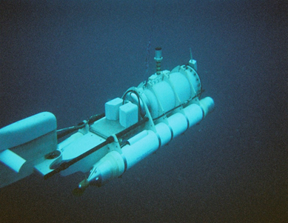

Fig. 2. AUV “X-3A”

For undersea navigation we use DVL&INS – “four beams” one, - of our own design with the accuracy – 0,3%.
AUV “X-3A” has DP (“Dynamic Positioning”) – to keep the position when it is needed with the seabed currents impact.
Till now AUV “X-3A” does not use any sonar equipment: forward or side-sonar, - the task does not need them and we do not want to enlarge the price. But they can be mounted in any time when the mission needs it.
AUV includes:
- Engines;
- Thrusters of DP («Dynamic Positioning»);
- Buoyancy Control System;
- Wireless Underwater Acoustic Video Communication System (with antennas orientation system);
- Acoustic Communication Command System;
- DVL/INS;
- SBL (“Short Base Line”) - AUV side;
- Central Processing System;
- Video Cameras;
- Lighting System;
- Radio System;
- System Emergency Ascent;
- Batteries;
- Strong case;
- Light case;
- Embedded software.
- GPS receiver;
- GSM(INMARSAT) modem;
- Search Magnetometer (“magnetic autopilot”);
- Mounting System for payload and its replacement;
- HUB of interfaces of payload.
Central Processing System is represented with “NVideo-560”: processors – 512 cores, 0,9 GHz.
Weight of AUV – less 200 кg.
Payload – less 20 кg.
Dimensions of AUV − less 2600х900х800.
Maximum speed of AUV “X-3A” − 5 knots.
AUV “X-3A” had been designed and tested for 2011-2015.
The difference of AUV “X-3A” from many solutions is: (1) the presence of “Dynamic Positioning” mode that critically needed in offshore but usually absent in UUVs; and (2) the “Automatic Routing System” also was implemented. With this AUV “X-3A” can be remotely controlled wirelessly by child with simple joystick! It differs AUV “X-3A” not only from ROVs – that needs very large and expensive trainings, − but also from most AUVs.
AUV “X-3A” can be adopted for other tasks concerning:
- mapping and profiling;
- raw materials exploration;
- archeology;
- rescue operations.

VESSEL

Of course to deliver AUV to the point of destination we need the vessel. In our case it is motor-sailing boat – MAEKSA.
BaltRobotics redesigned a vessel from the former German Fishing Seiner made in 1935… In Fig.3 – one page of German Fishing Seiner Project dated of 1935. In Fig.4 – “marine laboratory” − Motor-Sailing Boat “MAEKSA”.

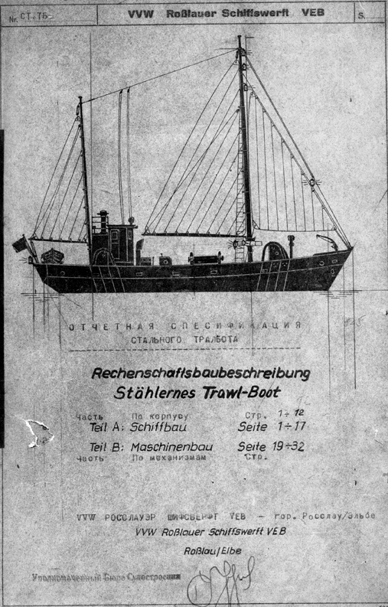

Fig. 3. Fishing Seiner, Germany – project 1935

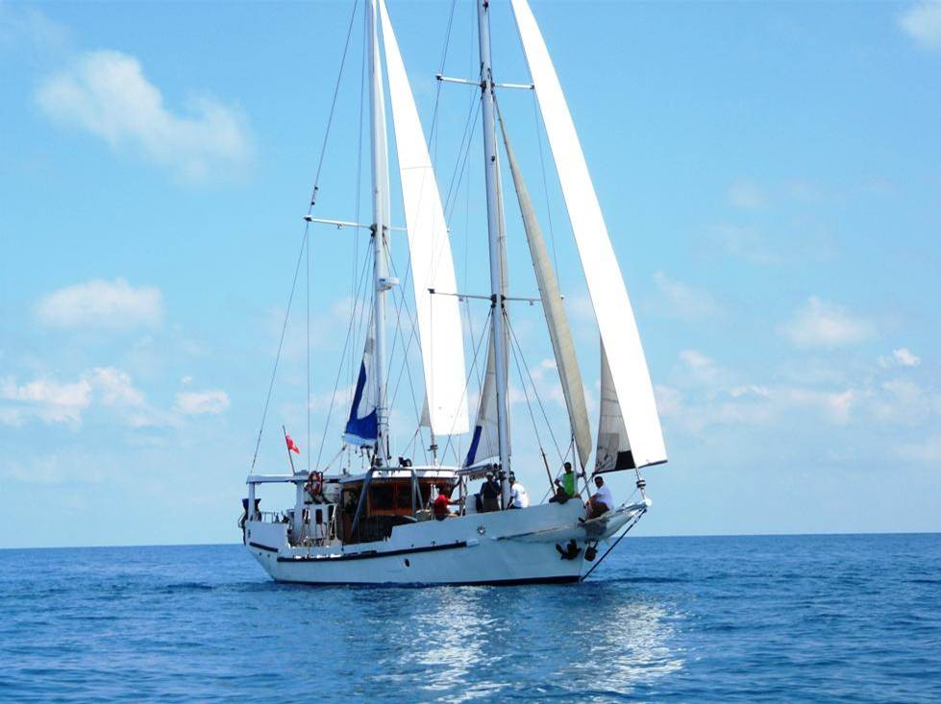

Fig. 4. Motor-Sailing Boat “MAEKSA” –
reincarnation

It combined special marine laboratories and scientific facilities. “Sailing-approach” delivers the possibility to keep fuel in most cases – in compare with ROVs we do not need to follow AUV in the missions. It also can be accounted that “Sailing Boat” approach has no limitations on the area of operations, and has many privileges in the channels, ports, etc. The tonnage of the carrier vessel with AUVs can be decreased 10 times that optimized the costs.
The Vessel is equipped with SBL (“Short Base Line” navigation system) with the range 200m and accuracy 3%.
The Vessel includes:
- Hull;
- Engines;
- Thrusters (DP);
- Sails («Bermudez»);
- Life support system;
- Anchoring system;
- GPS-navigation system;
- Radio system;
- System of underwater communication with AUV (video, command);
- LBL-navigation system (“Long Base Line”);
- Launch system for AUV;
- Submerged platform of AUV communication;
- Servers;
- Local network;
- Solar Batteries;
- Mechanical, electronic and chemical workshops;
- crew cabins.

DEMONSTRATION IN MALTA

21 May 2015, BaltRobotics held the live demonstration of the Vessel & AUV complex in Malta (St. Julian’s Bay, Sliema).
In Fig.5 – live on-line video of the target with the signatures of the participants of the Demonstration – the approach usually used by BaltRobotics to prove that all one see – not the trick!
The publications of the event had been made in the magazines by the company and
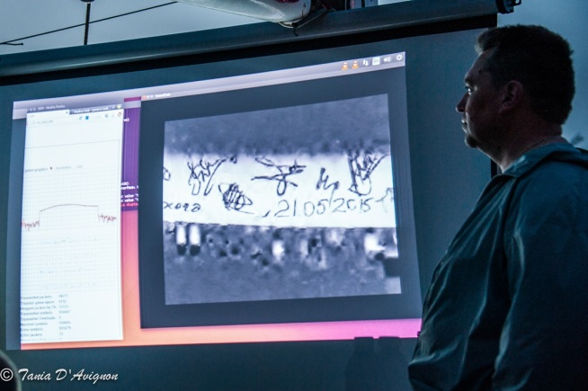

Fig.5. Wireless Underwater Acoustic Video transmitted from AUV “X-3A” “on-line” with the signatures of the participants of the Demonstration

the invited experts from Polish Navy Academy [12].
BaltRobotics is cooperating with Polish Navy Academy and “International Dialogue on Underwater Munitions” (IDUM) on the issue of chemical munitions from Germany arsenal which were flooded in the Baltic Sea after WWII. It is not very understood that in the Baltic Sea there are more 300000 ton of chemical munitions (gross weight) and more 60000 ton “pure materials” (“net weight”)! The half – in Skagerrak channel near Sweden seashore and the other half – on the area more 2100 sq.km in front of Poland, Lithuania, Latvia. This is very large dangerous and in the nearest future it has to be overcome.

PUBLICATIONS

There were published several articles [13, 14].
BaltRobotics representatives took part in several international conferences with the reports in particular in AOG-2017, Perth, Australia.
In 2016 BaltRobotics had been selected as one of the “20 finalists” of the Award: "START UP WORLD-2016" in the nominations “Automatics & Robotics” with the solution "Wireless Underwater Acoustic Video Communication Channel − "AUV-based one” [15].

CONFIGURATION AND CHANNEL CHARACTERISTICS

System Parameters and Specification of Wireless Underwater Acoustic Video Communication Channel are below.
Acoustic High Data Rate Modem:
- working distance – till 0,2 km;
- data rate – 115,2 kbit/s;
- full duplex mode;
- interface – Ethernet.
Antenna with Positioning & Control
System:
- frequency − 500 kHz/1000 kHz;
- beam width – 4°.
Video Camera: 720 x 640.
Video Blaster: Black Magic.
PC & “NVideo-560” (processors – 512 cores, 0,9 GHz).
Underwater Unit Software for Video Compression of “UltraVNP-Compression Algorithm”:
- 0,02 bit per pixel;
- 30 frames per sec.
Vessel Unit Software for Video Decompression of “UltraVNP-Compression Algorithm”: buffering − 0,1 s.

PROSPECTS

The research conducted by BaltRobotics revealed the principal limit for wireless underwater acoustic video – 500 m, – it hardly can be overcome in the nearest future. In the current plans of the company to enlarge the working distance of wireless video to 350m.

VIDEOS

Technology:
http://www.baltrobotics.com/.
The first wireless underwater acoustic video – AUV-based:
https://www.youtube.com/watch?v=lgiOv0hNZKE.
Remote Control of AUV “X-3A” and Automatic Routing:
https://www.youtube.com/watch?v=MVoFUraVyp0.

SOME AFTERTHOUGHTS

The world ocean became the main source of recourses increasing of the human population in the future. In the article [16] mentioned the first steps had been done in this direction. The importance of ocean resources and the attention they attract from the leading countries can be seen in the example of the United States: all air-space companies of the country every year are increasing “ocean budgets”: NASA, Boeing, Lockheed-Martin, others. The leading company with the largest in the world ROV-fleet is “Oceaneering”, – 100% owned by Boeing. NASA has more 10% of the budget for ocean exploration! The “space #1” just now is the Ocean! The real space is becoming the “space #2”.

BaltRobotics
“BaltRobotics Sp.z.o.o.”®, Gdansk, POLAND (http://www.baltrobotics.com/) − is a scientific research, design, development, and engineering business specializing in the area of the competences that includes in particular: engineering in robotics, telecommunications, navigation (AUV, UGV).
BaltRobotics had been established in Poland by several Ukrainian specialists in 2013.
The key personnel have large experience gained whilst working in former Soviet Union defense industry and state scientific research institutes.
The leading specialists and management staff of the company were the project managers in many international projects, and they were awarded with prestigious prizes, in particular: “Start Up World-2016”, “Gold Medal” of Brussels Exhibition “Eureka 2006” and the Medal of US Department of Defense − DARPA – for the robots’ racing (UGV) − “Grand-Challenge 2005”, and also were awarded with the medals of Exhibition “VDNH of USSR”.

REFERENCES

- Douglas-Westwood Market Report: http://www.douglas-westwood.com/.
- Wilby B. and others, 2016. Reviewing the global ROV-market, WORLD PIPELINES, Vol.16, Nr.4.
- Unmanned Systems Technology (UST) magazine, 2015. http://www.
unmannedsystemstechnology.com/category/supplier-directory/platforms/uuv-manufacturers/.
- Nichols B., 2013. Surveying the field in the search for fully autonomy, Offshore Engineer, January.
- Evologics, 2017. https://www.evologics.
de/en/products/acoustics/s2cm_series.html.
- Zheng Y.R. and others, 2007. Frequency-domain channel estimation and equalization for single carrier underwater acoustic communications, in Proceedings of MTS/IEEE OCEANS conference, Vancouver, BC, Canada, Sep.29 − Oct.4.
- Applied Ocean, 2017. http://www.
applied-ocean.com/see-horse-modem.html.
- Springer Handbook of Ocean Engineering, 2016. Edited by Manhar R. Dhanak, Nikolas i. Xiros, Springer, N.Y.
- Pontbriand C. and others, 2015. Wireless data harvesting using the AUV Sentry and WHOI optical modem, in Proceedings of MTS/IEEE OCEANS 2015, Washington, D.C., USA. http://toc.proceedings.com/ 29426webtoc.pdf; AUV Sentry − http://www.whoi.edu/main/sentry.
- Kwon H. and others, 1997. Very low bit-rate video coding using variable block-size entropy-constrained residual vector quantizers, IEEE J. Select. Areas Commun, Vol.15, 1714-1725.
- Infield Market Report, 2015. http://
www.infield.com/market-forecast-reports/.
- Pachek B., 2015. Wireless Underwater Acoustic Video Communication, ROV Planet, Issue 04, 39-43. http://issuu.com/rovplanet/
docs/rovplanet_magazine_04_web_/38?e=13380389/14076867.
- Otradnov K., Kornieiev S., 2015. The AUV approach, World Pipelines, Special Issue Coatings&Corrosion, 63-66. https://drive.google.com/open?id=0B-8eS9GaQlqFeGF4eXVkN0F3eXM.
- Otradnov K., Shuliak V., Sergii Kornieiev S., 2016. Underwater Wireless Video Communication – new horizon of underwater explorations, HYDRO International, Vol.20, Nr.7, 2016, 20-22. https://www.hydro-international.
com/content/article/underwater-wireless-video-communication.
- Start Up World-2016. http://www.
start-up.world/index.php#awards.
- Kulikov P., Suckach M., 2015. About readiness of Ukraine of mastering minerals of world ocean, Underwater Technologies, Vol.02, 3-10 (Ukraine).

Подводная беспроводная видеосвязь
в операциях AUV/UUVs –
новые горизонты подводных исследований

Кирилл Отраднов, Владимир Шуляк,
Сергей Корнеев

Аннотация. Представлен опыт компании BaltRobotics® в разработке, производстве и тестировании беспроводного подводного акустического канала видеосвязи – уникальной в мире технологии в настоящее время. Также рассматривается применение подводной беспроводной видеосвязи в интеграции с подводными автономными аппаратами типа AUV (Autonomous Underwater Vehicles) применительно к задачам неразрушающих инспекций подводных нефтегазопроводов и в других приложениях. Представлены достигнутые характеристики, ограничения и перспективы развития.
Ключевые слова: беспроводная подводная видеосвязь, акустика, подводные аппараты, AUV, ROV, оффшорная нефтегазодобыча, неразрушающие методы контроля, NDT, инспекции подводных нефтегазопроводов.

